NPA Photography

**Challenge 1 - A DAY IN THE LIFE OF ME**

During this project you will attempt to show a typical day in the life of you.

Try to take between 6 and 10 photos if you have access to a phone or a camera.

think about interesting compositions.

here are a few ideas to get you started…

* your breakfast
* a made bed
* exercise
* family
* home learning
* a meal
* pets

If you can, please upload your work to Teams.

Give your work the title: Challenge 1

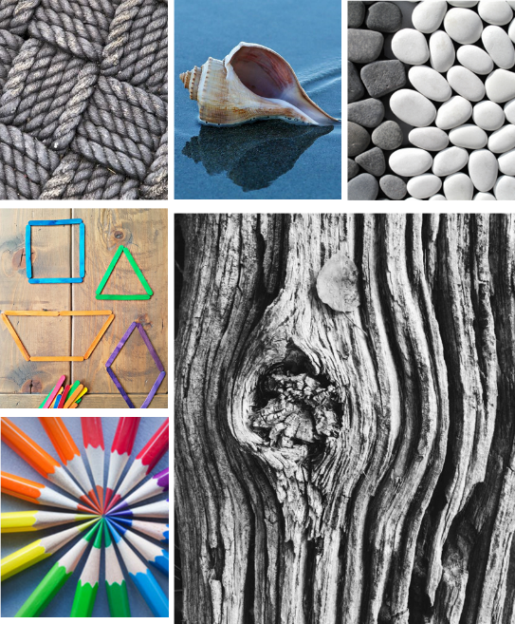**Challenge 2 THE VISUAL ELEMENTS**

During this project you will attempt to show the visual elements.

Create a PowerPoint illustrating each of the Visual Elements listed. If you are not sure about the meaning of any of these visual elements use the internet for explanations.

Think as creatively as you can, use the indoor environment around you to take the images. Use your phone or a camera at home to take the images.

If you cannot take photographs, find photographs on the internet that show these visual elements.

Choice 1: Take 1 or 2 photos of each visual element.

Choice 2: find photographs on the internet that show each of the visual elements.

The visual elements are below so you know what they are.

